**Columbia College**

**English for Professional Purposes (ENG0102)**

**Lecture 1**

**Course** **Outline**

Semester Dates: April 21, 2025 – May 24, 2025

|  |  |
| --- | --- |
| Facilitator: Linda Winfield | Email: linda.winfield@columbia.ca |
| Class Time: 5:30 PM - 9:30 PM (Tues/Thurs.) | Room: Online class (MS Teams) |
| Credit: Non-Credit Course | Prerequisite: None |

Note: It is the student’s responsibility to be familiar with the information contained in the Course Outline and to clarify any areas of concern with the facilitator.

When a holiday falls on a scheduled class day or a class needs to be rescheduled, a make-up class will be scheduled for Friday. Students are required to make arrangements to be present at the rescheduled class.

**Course Description:**

This course is designed to prepare students with the literacy skills and knowledge needed to enter into professional college-level programs. The course develops proficiency in various forms of writing, critical thinking and analysis, listening and speaking, and examination of various forms of reading materials. There is a concentration on writing essays and personal reflections. (5 weeks, 40 hrs.)

Classes are held online. Students will need access to a computer, a microphone, a camera, and a reliable internet connection during the scheduled class times. Instructions and login information for Microsoft Teams (online classroom) and Moodle will be provided to new students before classes begin.

**The final exam will be held on campus.  All students living within a 130 km radius of Calgary are expected to attend in person. The college is committed to following Alberta Health protocols for pandemic safety.  Depending on public health measures, the exam may be moved online.  Should this change occur, adequate notice will be provided to the students.    Students who live more than 130km from Calgary should notify the principal of Academic Upgrading by the end of Class 1 if alternative arrangements are needed.**

**Learning** **Outcomes:**

As a result of active participation in these sessions, a student can expect to:

* Use a variety of appropriate strategies to explore, comprehend and analyze texts both individually and in collaboration with others;
* Apply knowledge of organizational patterns and structural features to understand purpose, content and effectiveness of a text.
* Respond to questions about assigned readings in written/oral form
* Create critical/analytical oral and written responses to a variety of texts
* Write unified and coherent paragraphs
* Understand how to use varied sentence structures to suit specific purposes
* Edit for spelling, punctuation, word usage, grammar
* Write well-developed short answers using appropriate style and word choice
* Demonstrate the skills of writing short essay type papers
* Demonstrate the skills of writing a reflective paper
* Demonstrate the skills of writing a persuasive essay
* Communicate orally in a competent and professional manner in various circumstances, including giving presentations
* Use language, both oral and written, to show respect and consideration
* Appreciate diversity of expression, opinion and perspective
* Set appropriate personal goals for participation in a group

**Course Format:**

This course uses a variety of teaching/learning methods including discussion, personal reflection, experiential exercises, student presentations, role-plays, group activities and especially case studies. Our faculty aims to create a learning environment where the learner is actively engaged in inquiry, critical thinking and problem solving. The classroom provides you with a place where you can learn with and from others in a cooperative and collaborative manner.

Learners are expected to take a very active part in class discussions and take responsibility for their own learning. Be a positive and co-operative team member. Columbia College uses a facilitation model of instruction where the facilitator’s role is to facilitate learning. The expectation is that students will come to class prepared with pre-class homework completed. The facilitator will engage learners in activities that are based on their completed homework and readings. An enthusiastic and positive approach in the classroom will create an atmosphere that will help every student develop the knowledge, skills and attitudes that are needed for success.

How students conduct themselves in our classes will, to a large extent, mirror their conduct in society and at a future work site. For example, if they have a tendency to ask questions, challenge the ideas of others in a respectful manner, draw out the best from their colleagues, and encourage both group development and task accomplishment in this class, it is likely they will do the same at work. A high level of student involvement and developing professionalism is expected in the classroom as learners work towards their goals.

**Required Textbooks and Equipment:**

Lipschutz, G., Scarry, S., & Scarry, J. (2020). *The Canadian Writer’s Workplace, 9th Edition.* Cengage.

Please call the Main Office (403-235-9300) to make arrangements for payment and textbook pick up.

**Homework Assignment Due for the First Class:**

This reading assignment is to be completed **BEFORE** your first class. You do not need to do all the questions, but you should understand the contents/techniques/ideas and be able to apply them before the quiz.

1. **Chapter 14. *The Canadian Writer’s Workplace.***
2. **Chapter 18. *The Canadian Writer’s Workplace.***
3. Be prepared for a quiz on this homework, during class 1.
4. Prepare 3 questions that have arisen from your reading that you would like to have answered. You will be instructed on how to submit these questions to your facilitator on the first day of your course

Please note: You will not be reading the text in class. Columbia College follows a facilitation model that requires everyone to participate in the class. Please ensure that you know as much as possible before the class begins because there is not time to go over everything before writing a quiz.

**Evaluation - Assessment of Student Performance:**

The final grade in the course will be based on the following elements. Wherever possible facilitators will use rubrics to assess your performance and offer feedback.

|  |  |  |
| --- | --- | --- |
| **Title of Assignment / Examination** | **Due Date** | **Weight** |
| Daily Tests | Classes 1 through 9 | 20% |
| Homework, Writing Activities – Reflections, Essays, and Student Engagement | Classes 1 through 9 | 20% |
| #1 Assignment – Formal Outline of an Article | Class 6 | 10% |
| #2 Assignment – In-class Formal Essay | Class 8 | 15% |
| #3 Assignment – Reading and Writing Portfolio | Class 9 | 5% |
| Final Exam - Location to be announced | Class 10 | 30% |

Please note that all homework and assignments are **due at the beginning of each class**.

**Grading:**

Grades for each component will be added together at the end of the semester. The final total will be translated to the Columbia College’s 4.0 grading scale as follows:

*Marking and Grading Conversion:*

|  |  |  |  |  |
| --- | --- | --- | --- | --- |
| **Description** | ***Letter Grade*** | ***Grade Points*** | ***Percentage Scale*** | |
| Excellent | A+ | 4.0 | 100 | 95 |
| A | 4.0 | 94 | 90 |
| A- | 3.7 | 89 | 85 |
| Good | B+ | 3.3 | 84 | 80 |
| B | 3.0 | 79 | 75 |
| B- | 2.7 | 74 | 70 |
| Satisfactory | C+ | 2.3 | 69 | 65 |
| C | 2.0 | 64 | 60 |
| C- | 1.7 | 59 | 55 |
| Poor | D | 1.0 | 54 | 50 |
| Failure | F | 0.0 | 49 | 0 |

**Learners wanting to enter the Dental Assisting and Nursing Programs must achieve a minimum of 75% on the final exam as well as receive a final mark over 75% to pass this course. Students entering the non-Diploma Programs will need 70% on the exam and 70% as a final grade to enter their programs.**

**Submission and Completion of Assignments:**

You are expected to **submit assignments by the due date**. If you are unable to submit an assignment on the due date, you **must request an extension before the due date** by filling out an *Application for Assignment Extension form (SSPP-F012)* that is to be **submitted to the Department Chair for approval**. This form is available on Columbia’s website, Bldg. 802 – Main Office and from Department Chairs. Any late assignments may be assessed with a marking penalty of 5% per day.

**Requesting an Examination Deferral:**

If you are requesting an exam to be deferred, you must submit an Application for *Deferred Examinations form (SSPP-F012)* to the Department Chair **within 48 hours of the missed examination date and time**. Applications for deferred examinations will only be considered due to medical or personal emergency. A medical certificate or other appropriate documentation may be required. This form is available on Columbia’s website, Bldg. 802-Main Office and from Department Chairs.

**Attendance Requirements:**

Columbia College believes that students are committed to their program and learning experiences. However, it is understood that there are times when students may be absent. Any absences can be viewed as a potentially serious disruption of the learning process and necessary achievement of the learning objectives. **Being late is also considered unacceptable** as it interferes with the learning opportunities of others. Unavoidable absences or lateness must be reported to the course facilitator in advance. Please refer to Columbia College’s *Attendance Policy and Regulations (ADM-P151)* for detailed information on Attendance Requirements.

**Academic Integrity:**

Academic dishonesty is a serious offence and can result in suspension or expulsion from Columbia College.

There is **no tolerance for academic dishonesty** and any student caught plagiarizing is subject to serious sanctions as outlined in the *Student Code of Conduct Policy (ADM-P229)*. Students are encouraged to familiarize themselves with this policy and avoid any behavior that could possibly be seen as cheating, plagiarizing, misrepresenting, or putting into question the integrity of one’s academic work.

**Student Conduct:**

It is the responsibility of each student to uphold the expectations and responsibilities outlined in the *Student Code of Conduct Policy (ADM-P229)* and any additional requirements established by your program.

Generally, each student will:

* be respectful and courteous toward others;
* demonstrate appropriate and supportive communication skills, and coach, assist, advise and otherwise support other students in their studies;
* manage any personal stress and conflict in a positive and resourceful manner, and assist others to do the same;
* be dressed in a manner appropriate for their workplace or learning environment, as established by the program;
* conduct themselves in a professional manner with regard to their communication with others and their behavior in class;
* conduct themselves with academic integrity in all of their learning activities, tests, exams, and assignments
* keep up with day-to-day classroom and course expectations.

**Important Dates:**

|  |  |
| --- | --- |
| ***Description*** | ***Date*** |
| Last to add/drop courses | 5 school operating days from the start of the semester OR before the third scheduled class, whichever is greater |
| Last day to withdraw without academic penalty | 50% or less of the semester has been completed |
| Final Examination | A final exam may take many formats. If a final exam is scheduled, it will be taken in an assigned room under the supervision of a Test Proctor. Students must be on time as they will not be permitted to enter once the exam has started. Exam schedules are available in each building on a bulletin board, as well as online at [www.columbia.ab.ca/exams](http://www.columbia.ab.ca/exams). It is the student’s responsibility to check this exam posting. |

**Appeals:**

Please refer to the *Student Appeal Policy (ADM-P177)*.

**Students with Temporary or Permanent Disabilities:**

Students with temporary or permanent disabilities or medical condition may apply for accommodations. To be considered for an accommodation, a student must register with Columbia College’s Accessibility Services by making an appointment with a Accessibility Services Advisor – Main Office – Bldg. 802 or emailing [accessibilityservices@columbia.ab.ca](mailto:accessibilityservices@columbia.ab.ca). The Department Chair or facilitator is not able to provide you with any accommodations without you taking this step. Please refer to Columbia College’s website to review *the Accommodation Policy and Handbook (ADM-P188)*.

**Student Support:**

Students should be aware that Life Coaching, Career and Disability Services, and Student Support Services (i.e. tutoring, academic strategists, etc.) are provided by Columbia College. Inquire how to request these services at the Main Office in building 802. It is the student’s responsibility to discuss their specific learning needs with the appropriate service provider.

**Class Schedule/Overview:**

Please note that this schedule is subject to change. Any changes or cancellations will be emailed to you. It is your responsibility to check the email address you have given to the school on a daily basis for any messages from the Department Chair/designate, facilitator or College Administration. It is the student’s responsibility to be familiar with the information contained in the Course Outline and to clarify any areas of concern with the facilitator.

Additional homework may be assigned in class.

|  |  |  |
| --- | --- | --- |
| Class Session | Topics | Pre-Class Readings & Assignments |
| 1 | * Introductions and Syllabus Review * Reading Strategies * 4 Stages of Writing * Discuss Assignment #3 - Portfolio Project [due class 9] | * **Chapter 14. & Chapter 18.** * **Prepare 3 questions on readings.** * Grammar Assessment Pre-test |
| 2 | * Questions and Homework Review Test * Paraphrasing and Summarizing * Paragraph Writing * Spelling and Vocabulary * Discuss Assignment #2 – In-class Essay [due class 8] | * **Ch. 15, Ch. 19 & Ch. 20.** * **Prepare 3 questions on readings.** * **Reflection and work on portfolio** |
| 3 | * Questions and Homework Review Test * Quoting and Answering Questions * Essay Writing * Spelling and Vocabulary * Discuss Assignment #1 – Formal Outline of an Article. [due class 6] | * **Ch. 16, & Ch.17** * **Prepare 3 questions on readings.** * **Sentence Skills as assigned by facilitator.** * **Reflection and work on portfolio** |
| 4 | * Questions and Homework Review Test * Style in writing * Reading- text comprehension and analysis * Spelling and Vocabulary | * **Ch. 21 & Article assigned by facilitator.** * **Comprehension Questions - bring to class.** * **Prepare 3 questions on readings.** * **Sentence Skills as assigned by facilitator.** * **Preliminary Essay response and work on portfolio** |
| 5 | * Questions and Homework Review Test * Reading-text comprehension and analysis * Writing Arguments * Spelling and Vocabulary | * **Ch.25. pp. 281-298 & Article assigned by facilitator, including Comprehension Questions.** * **Prepare 3 questions on readings.** * **Sentence Skills as assigned by facilitator.** * **5-Paragraph Essay response and work on portfolio** |
| 6 | * Questions and Homework Review Test * Reading-text comprehension and analysis * Writing about Process * Concluding Activity | * **Ch. p. 324-333 & & Article assigned by facilitator.** * **Prepare 3 questions on readings.** * **Sentence Skills as assigned by facilitator.** * **5-Paragraph Essay response and work on portfolio** * Assignment #1 – Formal Outline of an Article will be completed in class. |
| 7 | * Questions and Homework Review Test * Reading-text comprehension and analysis * Writing Description | * **Ch. 29 pp. 334-345 & Article assigned by facilitator including Comprehension Questions.** * **Prepare 3 questions on readings.** * **Sentence Skills as assigned by facilitator.** * **5-Paragraph Essay response and work on portfolio** |
| 8 | * Questions and Homework Review Test * Reading-text comprehension and analysis * Writing Narratives | * **Ch.32 pp. 364-375 & Article assigned by facilitator including Comprehension Questions.** * **Prepare 3 questions on readings.** * **5-Paragraph Essay response and work on portfolio** * Assignment #2 – In-class Essay will be completed in class |
| 9 | * Course evaluation * Portfolio Conferences and Sharing * Grammar Assessment Post test * Exam Preparation | * ***Sentence Skills as assigned by facilitator.*** * ***Review spelling and vocabulary. (Appendix A in text and online appendix C)*** * **Prepare 3 questions on readings.** * Assignment #3 - Portfolio Project |
| 10 | **3-hour In Person Final Exam – location to be announced** | |

**Appendix 1**

**Assignment Outlines**

**ASSIGNMENTS – All assignments must be completed and handed in order to meet the requirements of English 102. All assignments are to be typed according to APA format. You may be required to send your completed assignments by email to the facilitator. This is a common practice in many professional programs.**

Please note that should there be **any evidence** of unintentional plagiarism, you will be **assigned a mark of “0.”** As we are here to help you to learn how not to plagiarize, you may be given the opportunity to rewrite the paper until you can see how a paper looks that does not contain plagiarism. Your mark will be an average of the marks attained throughout the efforts to rewrite the paper without calculating in the “0.” The facilitator will determine how many times an individual must write the paper in order to score an acceptable grade above “0.”

**Assignment #1 – Formal Outline of an Article** **Value 10%  
 Due: Class 6.**

After an introduction in class #3, the students will be asked to complete a template using the assigned readings *for practice and class discussions* [classes 4&5 homework].

During class #6, using an article provided by your facilitator, develop a formal and detailed outline of the article using the outline template also provided by your facilitator.

**Assignment #2 – In-class Writing of Formal Essay  
 Value 15%** **Due: Class 8.**

During the class, you will be given 90 minutes to complete a 5-paragraph essay using the knowledge you have gained during the course. The facilitator will provide you with the topic and any articles needed for background information. **Discussed in Class 2.**

**Assignment #3 – Reading and Writing Portfolio  
 Value 5%  
 Due: Class 9.**

Throughout the course you will develop a portfolio of work that demonstrates the skills and knowledge you have acquired during the course. You will also be completing daily reflections on your learning and reading that will be included in your portfolio. Complete details concerning what should be in the portfolio will be provided by your facilitator during Class 1. **Assigned in Class 1.**

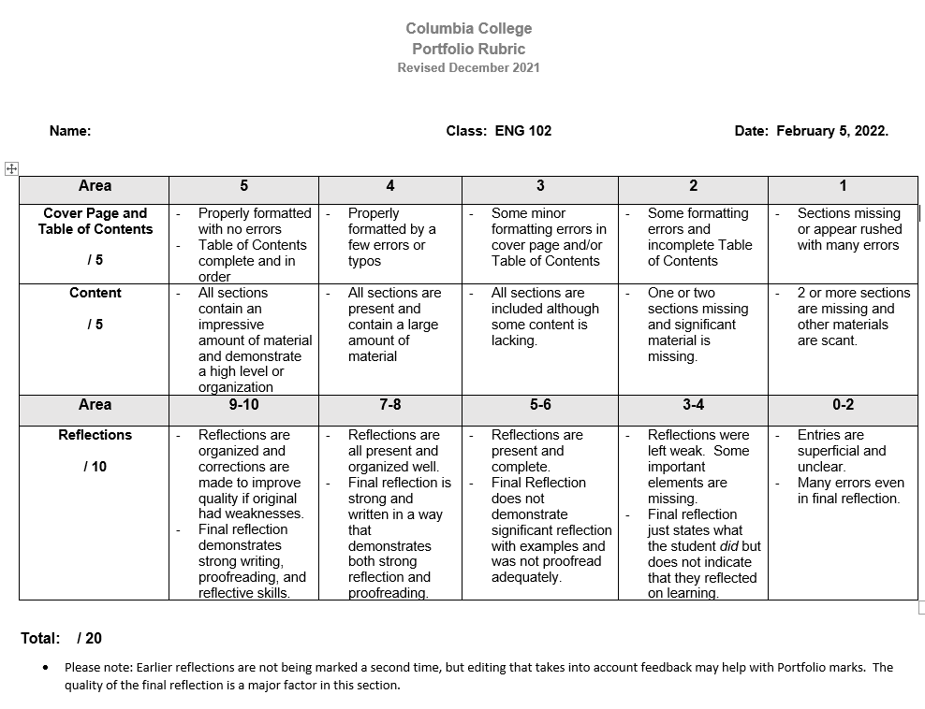

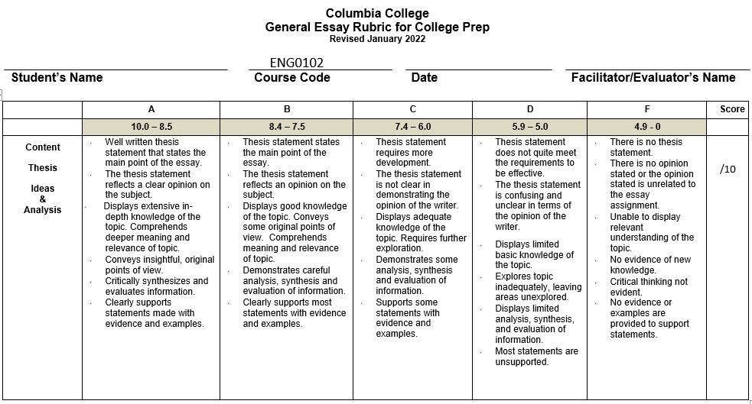

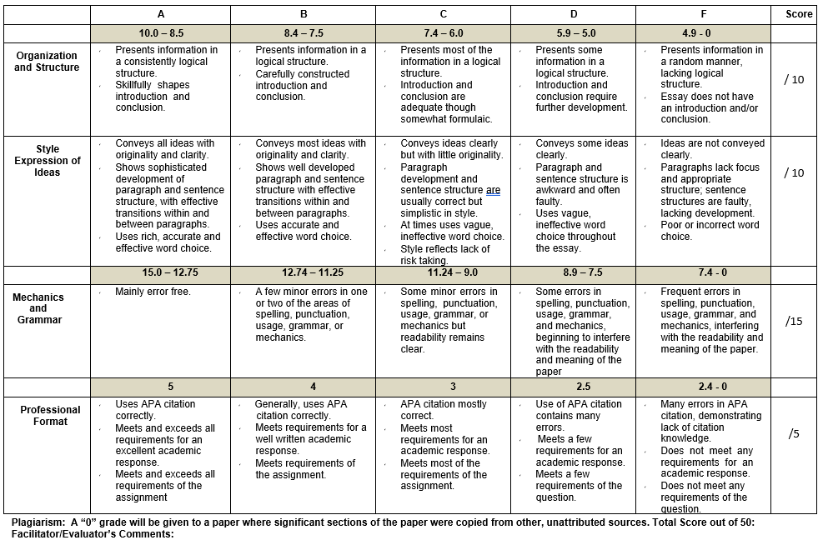

**Thesis statement: topic + your opinion / answer to the question.  Restate thesis statement in paragraph of conclusion - mirror image / slightly different words.  Start with a point – topic sentence with hook.  End your essay with a point / your final thought. Provide examples in body paragraphs. Use transitions *within* and *between* body paragraphs.**